A Project Report
On
Multiplayer Dungeon Quest
Submitted in partial fulfillment of the requirement of
Project – IV (BIT106CO)
BACHELOR IN INFORMATION TECHNOLOGY
Submitted to

Purbanchal University
Biratnagar, Nepal

Submitted by
Bhavishek Lama (342678)
Hulas Chandra Chaudhary (342686)
Ravi Kumar Hathi (342696)

KANTIPUR CITY COLLEGE
Putalisadak, Kathmandu
Dec, 2025
A Project Report on

Multiplayer Dungeon Quest

Submitted in partial fulfillment of the requirement of
Project – IV (BIT106CO)

BACHELOR IN INFORMATION TECHNOLOGY

Submitted to

Purbanchal University
Biratnagar, Nepal

Submitted by
Bhavishek Lama (342678)
Hulas Chandra Chaudhary (342686)
Ravi Kumar Hathi (342696)

Project Supervisor
Er. Ronak Singh Karki

KANTIPUR CITY COLLEGE
Putalisadak, Kathmandu
Dec, 2025

Abstract

Dungeon Quest is a 2D multiplayer action-adventure game developed in Java, designed to deliver an engaging and collaborative gaming experience. Players control characters navigating a procedurally generated 50x50 tile-based dungeon, composed of ground, walls, water, and obstacles, rendered using sprite-based graphics.
The game leverages object-oriented programming principles to implement core mechanics such as sprite animation, collision detection, and real-time input handling. Players explore the dungeon, avoid obstacles, and engage in combat with enemies using keyboard-controlled movements and attacks. The multiplayer feature allows multiple players to join the same game session, cooperating or competing within the dungeon environment. The game’s modular architecture, with distinct classes for the game panel, player entities, background management and socket programming, ensures scalability and maintainability. A thread-based game loop drives the core mechanics, updating game states and rendering graphics at a consistent 60 FPS.
Dungeon Quest blends nostalgic dungeon-crawler aesthetics with multiplayer dynamics, offering a challenging and interactive experience while serving as a practical demonstration of Java-based game development and networked gameplay.

Acknowledgement

We’d like to express our heartfelt gratitude to everyone who has encouraged us to work on this project. First and foremost, we’d like to express our gratitude to the entire team of Kantipur City College (KCC) for this chance, especially the department of science and technology, who assisted us in furthering our knowledge in this field.
And we’d like to express our special gratitude to our supervisor, Er. Ronak Singh Karki. who has consistently encouraged, inspired and provided us with a wealth of information that has been beneficial. His advice was helpful in completing this project. We could not have asked for a better supervisor, counselor, or mentor.
This project would not have been possible without the assistance of each member, who offered suggestions, shared their experiences, and provided advice throughout the project. We are grateful for this. Finally, we’d like to express our gratitude to our teachers, friends and colleagues who supported us directly and indirectly throughout this project.

Declaration

I declare that this semesters project report titled “Multiplayer Dungeon Quest” submitted in partial fulfillment of the Bachelor of Information Technology, is a record of original work carried out by me under the supervision of Er. Ronak Singh Karki. This work has not been submitted for the award of any other degree at this or any other institution or university. In keeping with the ethical practice of reporting scientific information, due acknowledgements have been made wherever the findings of others have been cited.

Bhavishek Lama
Hulas Chandra Chaudhary
Ravi Kumar Hathi

Supervisor’s Approval

This is to certify that this semester the project entitled “Multiplayer Dungeon Quest” undertaken and demonstrated by Bhavishek Lama, Ravi Hathi and Hulas Chandra Chaudhari has been successfully completed under my supervision as a partial fulfillment of the requirements of the degree of BIT 4th semester under Purbanchal University. I, henceforth, approve this project to be awarded the certificate by the concerned authority.

During supervision, I found students hardworking, skilled and ready to undertake any professional work related to this field in the future.

_______________
Er. Ronak Singh Karki
Project Supervisor
Department of IT
Kantipur City College

Certificate from Department

Following the Supervisor's Approval and Examiners' Acceptance, the project entitled “Multiplayer Dungeon Quest” submitted by Bhavishek Lama, Ravi Hathi and Hulas Chandra Chaudhari as a partial fulfillment of the requirements for the degree of BIT 4th under Purbanchal University, has been officially awarded by this certificate. I wish the students all the best for their future endeavors.

______________
Saroj Pandey
HoD
Department of IT
Kantipur City College

______________
Rubim Shreasth
Project Manager
Department of IT
Kantipur City College

Table of Contents
Abstract iii
Acknowledgement iv
Declaration v
Supervisor’s Approval vi
Certificate from Department vii
Chapter 1: Introduction 1
1.1 Overview 1
1.1 Problem Statement 1
1.3 Objectives 2
1.4 Features 2
1.5 Significance 3
1.6 Scope and Limitations 3
1.7 Documentation Organization 3
Chapter 2: Literature Review 4
2.1 Background 4
2.1.1 Overview of Existing System 1 (Shattered Pixel Dungeon) 4
2.1.2 Overview of Existing System 2 (Elona+) 4
2.1.3 Multiplayer Architecture in Java (StackOverflow Post 29545597) 5
2.1.4 Using Data from Client Handler Threads (StackOverflow Post 43498392) 5
2.2 Analysis of Literature Review 6
Chapter 3: Methodology 7
3.1: Software Development Life Cycle 7
3.1.1: Selected Model 7
3.2 Technologies and Tools used 8
3.2.1 Programming Language 8
3.2.2 Database 8
3.2.3 Integrated Development Environment (IDE) 9
3.4 Roles and Responsibilities 9
Chapter 4: System Analysis 11
4.1 Requirement Analysis 11
4.1.1 Requirement Gathering 11
4.1.2 Functional Requirement 12
4.2 Feasibility Study 12
4.2.1 Technical Feasibility 13
4.2.2 Economics Feasibility 13
4.2.3 Schedule Feasibility 13
4.2.3.1 Gantt chart 13
Chapter 5: System Design and Implementation 14
5.1System Architecture of Dungeon Quest (Multiplayer 2D Game) 14
5.1.1 High-Level Overview 14
5.1.2 Client Architecture 14
5.1.3 Server Architecture (socket_and_Jdbc) 16
5.2 Diagrams 17
5.2.1 DFD Level 0 17
5.2.2 DFD Level 1 18
5.2.3 Use case Diagram 19
5.2.4 ER-Diagram 19
Chapter 6: Testing and Debugging 20
6.1 Tools used in Testing 20
6.2 Test case 20
Chapter 7: Conclusion 25
Chapter 8: References 26

List of Figure
Figure 3.1: Waterfall model.. 7
Figure 4.1: Gantt chart 13
Figure 5.1 DFD level 0 17
Figure 5.2 DFD level 1 18
Figure 5.3: Use Case Diagram 19
Figure 5.4: ER-Diagram 19

List of Table

Table 2.1: Analysis of Literaature Review 6
Table 3.1: Role and Responsibilities 9
Table 4.1: Requirement Gathering 11
Table 4.2: Functional Requirement 12
Table 6.1: Tools used in Testing 20
Table 6.2: Test Case 20

Chapter 1: Introduction

Dungeon Quest Multiplayer is a 2D dungeon-exploration and socialization game developed in Java. The project focuses on creating a simple and interactive game environment where multiple players can join the same dungeon and see each other’s movement in real time. The game uses socket programming for multiplayer communication and a database system to store player accounts and login details. This project is both entertaining and educational, helping students learn game logic, networking, and database integration.

1.1 Overview
The game begins with a menu where players can log in or create a new account, then start the game, each player controls a character and can move around the map using keyboard controls. The client constantly sends the current player position to the server using socket programming. The server then broadcasts the updated positions of all connected players back to every client. This ensures that every player can see the movements of others in real time.
Players can explore the dungeon, avoid obstacles, and interact with other players while facing numerous challenges. The game’s mechanics focus on movement synchronization, collision detection, and efficient communication between client and server. A database is used to store information such as player login details and their items.

1.1 Problem Statement
Many classic 2D dungeon games offer engaging gameplay and exploration, but most of them are restricted to single-player mode, limiting real-time interaction between players. The goal of this project is to develop a multiplayer dungeon-based game where players do not play in isolation. Instead, they can see each other, move around the same environment, and experience a shared game world. The challenge lies in overcoming limitations such as lack of real-time communication and absence of player synchronization. Dungeon Quest aims to solve these issues by implementing socket-based multiplayer networking and database-driven user management.

1.3 Objectives
The objectives of the proposed project are as follows:
- To develop a simple and interactive dungeon-exploration game using Java.
- To implement real-time multiplayer functionality using client–server socket programming.
- To store and manage player data using a relational database.
- To design a smooth movement and position synchronization system between players.
- To apply object-oriented concepts, event handling, and collision detection to build structured game logic.

1.4 Features
The features of the space impact are as follows:
- Real-Time Multiplayer System: Multiple players can join the same dungeon
- Player Position Synchronization
- Database Integration: Stores player login details
- Interactive Map Navigation: Players can move freely inside the dungeon
- User-Friendly Controls: Simple keyboard movement controls
- Login and Registration System: Players can securely create an account or log in before entering the game.
- Real-Time Collision Detection: Players cannot pass through walls or restricted zones in the map.
- Players interaction: players can chat with each other while playing games

1.5 Significance
Dungeon Quest Multiplayer helps students and beginners understand how modern games handle networking, movement synchronization, and database systems. It shows how multiple technologies—Java, sockets, and MySQL—work together in a single project. This makes the game both fun to play and valuable for learning.

1.6 Scope and Limitations
Scope:
The scope of Dungeon Quest Multiplayer is to develop a 2D dungeon exploration game that allows multiple players to interact in real time within the same map. It includes essential features such as player account creation and login using a database, smooth character movement, collision detection, and real-time position updates through socket programming. The project demonstrates core concepts of game development, networking, and client-server communication, serving as a practical learning platform for understanding multiplayer game mechanics.
Limitations:
While developing the program we thought of adding some more features but couldn’t due to our inefficiency
- Basic 2D map design with limited visual elements.
- Dependent on stable local network for smooth multiplayer performance.
- Leveling mode

1.7 Documentation Organization
This documentation provides a complete overview of the Dungeon Quest multiplayer project. Chapter 1 introduces the background, objectives, features, and overall significance of the game. Further chapters describe the system design, detailed operation of multiplayer synchronization, database structure, networking workflow, and implementation details. The report also highlights how the game differs from existing systems and explains the real-time client–server communication process.

Chapter 2: Literature Review

2.1 Background
We played and reviewed many similar games to familiarize ourselves with the dungeon crawler we are trying to make. Among all the games, two of them were particularly similar to our project, but as expected, they shared similarities in graphics and features while offering unique elements for inspiration.

2.1.1 Overview of Existing System 1 (Shattered Pixel Dungeon)
Shattered Pixel Dungeon is a traditional roguelike dungeon crawler RPG, available on platforms like Android, iOS, and Steam. Players control a hero descending through procedurally generated dungeon levels, fighting enemies, collecting items, and managing resources in a turn-based grid system with pixel art graphics. The game emphasizes replay ability through randomization, class choices (warrior, mage, rogue, huntress).
Pros:
- Infinite replay ability through procedural generation
- Strategic depth and mechanics
- Simple yet addictive gameplay loop
Cons:
- Steep learning curve for new players
- No multiplayer support
- No progression saves
- frequent deaths

2.1.2 Overview of Existing System 2 (Elona+)
Elona+ offering an open-world sandbox experience with roguelike elements. Players create a character from various races and classes, exploring a vast overworld, completing quests, breeding monsters, and delving into dungeons in a turn-based system with tile-based graphics. It features deep simulation mechanics.
Pros:
- Better graphics
- Highly customizable open-world
- Forgiving mechanics compared to traditional roguelikes
Cons:
- Overwhelming and confusing for beginners due to complexity
- Single-Player
- Limited QoL features

2.1.3 Multiplayer Architecture in Java (StackOverflow Post 29545597)
StackOverflow hosts a discussion on how to implement multiplayer functionality in Java using a reliable networking structure. In this post, one of the contributors explains that games should use a client–server model instead of letting players connect directly to each other. The server should be responsible for creating game sessions, managing players, and handling all communication.
Pros:
- Provides a stable and reliable connection for all players.
- Avoids problems found in peer-to-peer connections.
- Makes it easier to manage game sessions and synchronize player actions.

2.1.4 Using Data from Client Handler Threads (StackOverflow Post 43498392)
Another StackOverflow discussion explains how to handle data from multiple client threads in a Java multiplayer server. The recommended approach is to pass a shared Game object to each client handler thread. Each thread works directly on this shared object whenever it receives data from its client. This design keeps the game state centralized and removes the need for the server to manually gather information from different threads later.
Pros:
- Each client thread can process incoming commands independently.
- All updates are applied directly to the shared Game object.

2.2 Analysis of Literature Review

Table 2.1: Analysis of Literature Review
Features | Shattered Pixel Dungeon | Elona+ | Our game
Open-world | Yes | Yes | Yes
Single player | Yes | Yes | Yes
Forgiving mechanics | No | Yes | No
Multiplayer | No | No | Yes
Progressive saves | No | Yes | No
Game sound | Yes | Yes | Yes

Chapter 3: Methodology

3.1: Software Development Life Cycle
By following an SDLC model, the development process can be broken down into manageable phases, allowing for better planning, tracking progress, and ensuring quality control. It also helps in identifying potential risks and errors at an early stage and addressing them effectively, which is essential when dealing with sensitive data such as supplier information and product management.
Additionally, using an SDLC model ensures that the final product meets the needs and expectations of all parties involved. Overall, incorporating an SDLC model in the development of a Multiplayer Dungeon Quest helps streamline the process, minimize errors, and deliver a reliable and efficient software solution.

3.1.1: Selected Model
For this project, an Iterative (Incremental) SDLC model was selected. This model combines the structured nature of traditional SDLC with the flexibility of iterative development. It is particularly suitable for small-scale, personal projects with limited timelines and evolving requirements.
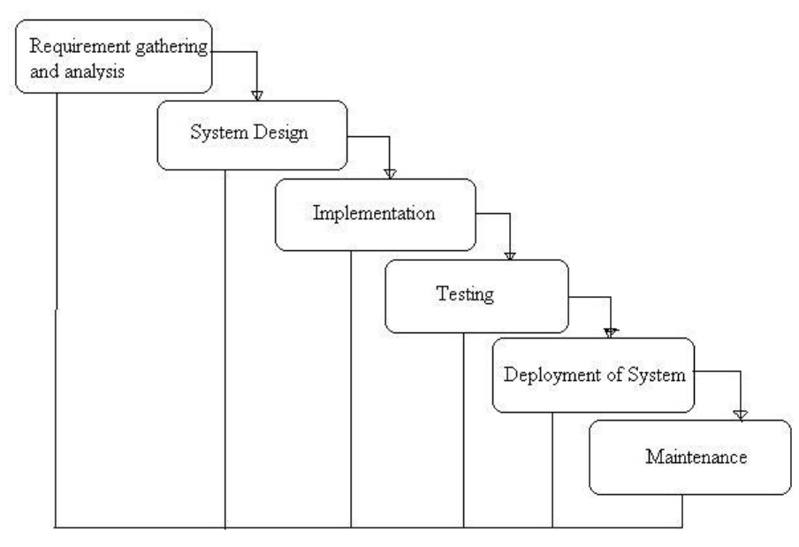
Figure 3.1: Waterfall model

The iterative model allows the system to be developed in small increments, where each iteration includes requirement analysis, design, implementation, and testing. Feedback from each iteration is used to improve the system in subsequent cycles.
Justification for Model Selection
- The project has a short development duration of few months.
- Requirements may evolve during development.
- Early delivery of a working prototype is beneficial.
- The model supports continuous testing and refinement.
- It reduces the risk of major failures at later stages.

3.2 Technologies and Tools used

3.2.1 Programming Language
The primary programming language used for the development of the Multiplayer dungeon quest is Java. Java is an object-oriented, platform-independent language widely used for building robust and scalable applications. Its strong support for modularity, security features, and extensive standard libraries makes it ideal for developing both backend logic and user interfaces. In this project, Java is used to implement core functionalities such as user registration, login, running multiple processes, multiple players, collision detection and movement synchronization.
The language also supports integration with databases through JDBC (Java Database Connectivity), which allows smooth interaction with the MySQL database for storing and retrieving player id and names, items, and inventory data. Additionally, Java’s compatibility with Swing enables the creation of interactive GUI components for the user interface.

3.2.2 Database
Multiplayer dungeon quest uses a relational database implemented with MySQL, managed through phpMyAdmin and hosted locally using the XAMPP server package. XAMPP provides an integrated environment including Apache web server and MySQL database, allowing efficient development and testing. The database operates on the default MySQL port 3306, ensuring reliable connectivity between the Java application and the database using JDBC. MySQL was chosen due to its robustness, ease of use, support for relational integrity through primary and foreign keys, and its suitability for handling structured data such as player id, player name, item names, items id and item quantity

3.2.3 Integrated Development Environment (IDE)
The project Multiplayer dungeon quest was developed using Visual studio code, which is an integrated development environment. Visual studio code provides a comprehensive set of tools for code editing, debugging, and project management, making it easier

3.4 Roles and Responsibilities

Table 3.1: Role and Responsibilities
Team Member | Task Performed
Bhavishek Lama | - Coding  - socket programming  - game handler  - background manager  - Documentation
Ravi Kumar Hathi | - Coding  - Database implementation  - Collision detection  - Player and map design  - Documentation
Hulas Chandra Chaudahari | - Coding  - Login, menu and pause panel  - Login, menu and pause logic  - Documentation

Chapter 4: System Analysis

4.1 Requirement Analysis
Requirement’s analysis is the process of identifying and documenting the functional and non-functional needs of a system. It helps in understanding what the system should do and how it should perform.
In this project, requirements analysis is carried out to identify the needs of the game developed using Java with HTML and CSS. The analysis focuses on defining secure login mechanisms, collision detection, player movement, sending player data over sockets and graphical performance visualization. Proper requirement analysis ensures that the system is secure, reliable, and easy to use for all users.

4.1.1 Requirement Gathering
Requirement gathering is the process of collecting information about user needs and system expectations. In this project, requirements were gathered through discussions with other project members, supervisor and classmates as well as by observing the existing games.
Table 4.1: Requirement Gathering
Requirement ID | Description
R1
  The game should authenticate old player
R2 | The game should be able to add new player in database
R3 | The game should add the player to server
R4 | The game should save items of the player
R5 | The game should refresh screen and draw every entity
R6 | The game should check for the collision of player and other entity.
R7 | The game spawn items for players
R8 | The game should provide inventory for players to equip items
R9 | The game should have end condition

4.1.2 Functional Requirement
Table 4.2: Functional Requirement
Function ID | Description | Cross Reference with Requirement
F1 | User authentication | R1
F2 | Game should check name of the new player and add them with na new player id | R2,R3
F4 | Sends the player invemtory with its own protocol | R4
F5 | The game refreshes the screen by calculating the next frames in the total interval | R5
F6 | We create a rectangle over player and calculate all the corners for the collision with the maps and other player | R6
F7 | The game spawn items for players by randomly generating the position of the ground | R7
F8 | The inventory is managed by sending the players item at the start by the server and the client system handles all the gracphical interface using swing | R8
R9 | When any player’s kill reaches 10 the game ends | R9

4.2 Feasibility Study
Feasibility study is conducted to determine whether the proposed system is practical, cost-effective, and can be completed within the given time frame

4.2.1 Technical Feasibility
The technical feasibility checks if we have the tools, skills, and technology to build the system. We are using Java, Visual Studio code, MySQL with XAMPP, Swing for UI, and libraries like MySQL Connector.

4.2.2 Economics Feasibility
The economic feasibility analysis evaluates whether the proposed system is financially viable and affordable. The project utilizes free and open-source development tools such as Visual Studio code and MySQL, thereby eliminating software licensing costs. Although the development team is small, the project is carried out over an extended period rather than a short duration; therefore, manpower cost may vary depending on the total number of working hours contributed by each team member.

4.2.3 Schedule Feasibility
Schedule feasibility analyzes whether the project can be completed within the available timeframe and deadlines. By following a step-by-step development plan (SDLC) and dividing tasks, we can complete coding, testing, and deployment within the semester. The clear features and small scope make the timeline achievable.

4.2.3.1 Gantt chart

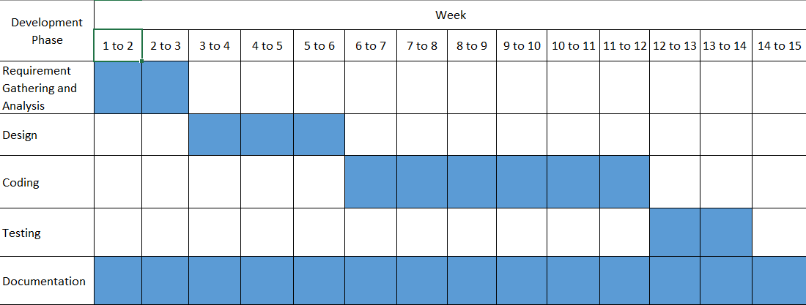
Figure 4.1: Gantt chart

Chapter 5: System Design and Implementation

5.1System Architecture of Dungeon Quest (Multiplayer 2D Game)
The project is a classic client-server multiplayer 2D top-down dungeon game built in Java Swing, with tile-based rendering, real-time multiplayer synchronization, database-backed player persistence, and basic inventory/chat features.

5.1.1 High-Level Overview
Client Side (packages: main, background, gameplayers, items)
- Runs the graphical game using Swing (JPanel subclasses).
- Handles user input, rendering, UI navigation (login → menu → game → pause/chat/inventory).
- Connects to the server via raw sockets for multiplayer.
Server Side (package: socket_and_Jdbc)
- Simple multithreaded socket server.
- Manages player authentication, position broadcasting, global chat, and inventory persistence using MySQL.

5.1.2 Client Architecture
Entry Point
- main.frame → creates JFrame with CardLayout containing all screens.
UI Flow (CardLayout panels in main)
- loginornew → login or newplayer → gamemenu → gamehandler (main game panel)
- From game: pausemenu, chat, inventory
Core Game Loop (main.gamehandler)
- Extends gamepannel (base panel with screen/tile sizes).
- Implements Runnable → runs at 60 FPS.
- Contains and coordinates:
- player (local player entity)
- backgroundmanager (tile map rendering)
- colisiondetection
- input (key listener)
- gameclient (networking)
- itemspawn (item placement – currently incomplete)
Entity System (gameplayers)
- entity ← base class (extends gamepannel – holds position, sprites, collision)
- player ← local controllable player
- OtherPlayer ← remote players (shares sprites from local player)
Rendering Layers
- background.backgroundmanager draws tile map (ground, walls, water, rocks) centered on player.
- Entities (player + other players) drawn on top.
- Full-screen backgrounds via background.loginphoto and background.pausebackground.
Items (items)
- All items inherit from itemsdetail (name, id, image, description, speed).
- Loaded with images in constructors.
Networking (main.gameclient)
- Connects to localhost:5555.
- Sends: LOGIN, REGISTER, MOVE, CHAT, INVENTORY requests.
- Receives: WORLD updates (all player positions), CHAT messages, INVENTORY data.
- Updates local OtherPlayer map and inventory list.

5.1.3 Server Architecture (socket_and_Jdbc)
Entry Point
- server.main() → ServerSocket on port 5555, accepts connections endlessly.
Per-Client Handling
- Each connection → new ClientHandler thread (implements Runnable).
- Shared static List<ClientHandler> allClients for broadcasting.
Protocol
- Plain text lines (e.g., "LOGIN|id", "MOVE|up", "CHAT|hello", "WORLD|id|name|x|y|dir|...").
Player Management (playercheck)
- All database operations (MySQL via JDBC).
- Checks ID/name uniqueness.
- Registers new players.
- Loads player inventory (PlayerItem list).
Broadcasting
- On every movement → broadcastWorld() sends current positions/directions of all connected players.
- Chat messages → added to static history and broadcast.
Persistence
- Players and inventory stored in MySQL database ("game" schema).

5.2 Diagrams

5.2.1 DFD Level 0

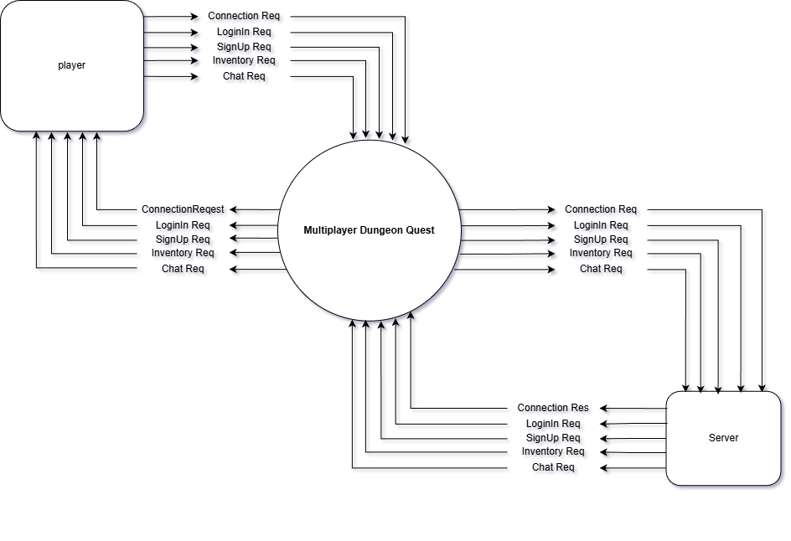
Figure 5.1: DFD level 0

5.2.2 DFD Level 1

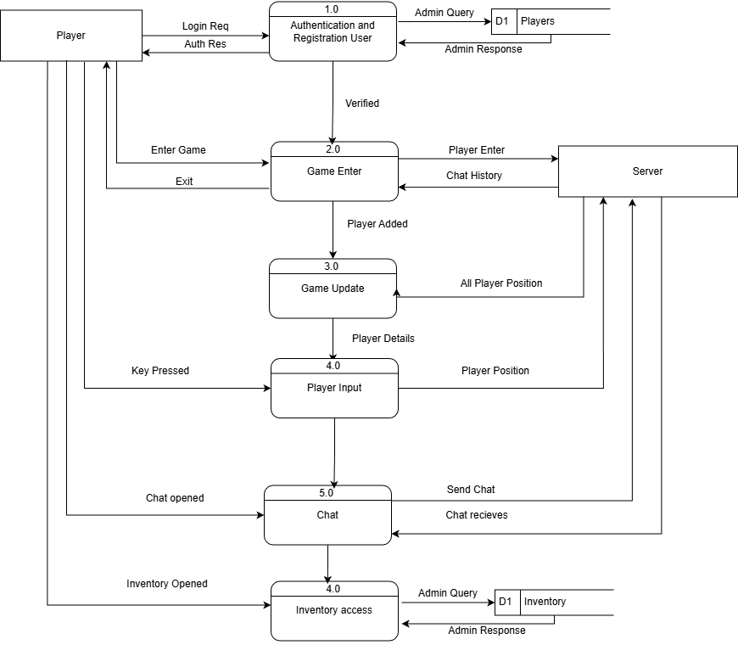
Figure 5.2: DFD level 1

5.2.3 Use case Diagram

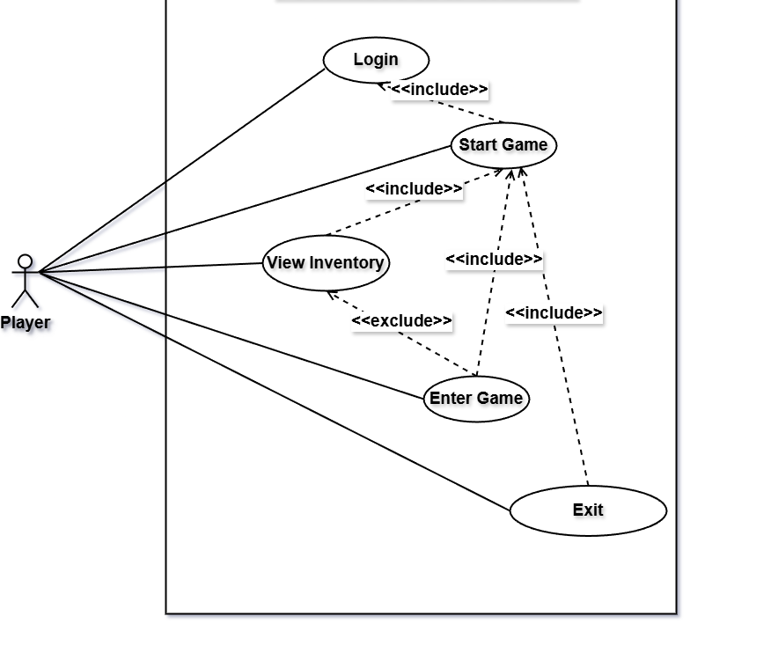
Figure 5.3: Use Case Diagram

5.2.4 ER-Diagram

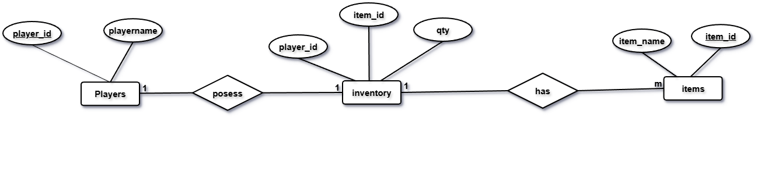fin
Figure 5.4: ER-Diagram

Chapter 6: Testing and Debugging

6.1 Tools used in Testing
Table 6.1: Tools used in Testing
S.N. | Tools | Specification
1 | Hardware (Laptop) | Acer nitro V 16 AMD Ryzen 7 8845HS  Dell Inspiron Intel Core i5-1135G7  Lenovo IdeaPad Intel Core i5-8548U
2 | Testing software | Visual studio code  Xampp control pannel

6.2 Test case
Table 6.2: Test Case
SN | Test objective | Expected Output | Result | Remarks
1 | Input valid login credentials | Show game menu when correct playerid id sumbitted | Invalid player id | Work on login
2 | Input valid login credentials | Show game menu when correct playerid id sumbitted | Game screen open | Added sleep for login flag
3 | Input invalid login credentials | Invalid player id | Invalid player id | Pass
4 | Signup: old player using same name | Name already exists | Name already exists | pass
5 | Signup: player using new name | Generates playerid and start game option | Name already exists | Work on query or player exist flag
6 | Signup: player using new name | Generates playerid and start game option | Generates playerid and start game option | Added sleep for player exist flag
7 | Signup: player using new name | Generates playerid and start game option | Unknown column detected | Error on database
8 | Signup: player using new name | Generates playerid and start game option | Generates playerid and start game option | Trigger had a unknown column “Quantity”
9 | exit | Close game window | Close game window | pass
10 | Receive chat history | Receive chat history and add the message in list | Chat received and added to list | pass
11 | Pressed inventory | Ask server for item list and Opens a panel that shows player items | Item list received but not displayed | fail
12 | Pressed inventory | Ask server for item list and Opens a panel that shows player items | Item list received and displayed the items in button | Items button created in list
13 | exit | Close game window | Close game window | pass
14 | Start Game | Add player in the map | Adds player to the map | pass
15 | Wasd key pressed | Player moves and sends player position to server | Player moves | Partially pass
16 | Wasd key pressed | Player moves and sends player position to server | Player moves and sends position | Added a function to send players position in player class
17 | P key pressed | Pause menu | Pause menu opens | pass
18 | Q/esc key pressed or resume button pressed | Back to game | Pause menu opens infinitely | fail
19 | Q/esc key pressed or resume button pressed | Back to game | Back to game | Added another flag for resume
20 | Back to menu button pressed | Back to game menu | Back to game menu | pass
21 | Exit button pressed | Close game window | Close game window | pass
22 | Pressed c for chat | Opens chat panel and shows chat history | Only Opens chat panell | Partial pass
23 | Pressed c for chat | Opens chat panel and shows chat history | Only Opens chat and shows history | Chat class created during start game and same instance used in chat pannel
24 | Pressed e for item | Opens inventory panel and shows items | Opens inventory panel and shows items | Pass
25 | Pressed mouse left for attack | Shoots projectile to the press position | Shows the projectile start and destination coordinate | Partially pass
26 | Pressed mouse left for attack | Shoots projectile to the press position | Projectile not visible | Added projectile function
27 | Pressed mouse left for attack | Shoots projectile to the press position | Shoots projectile | pass
28 | Projectile collision detection | When projectile hits the other player, walls or stones it should disappear and get deleted | Projectile passes through every thing and hits player | Partial pass
29 | Projectile collision detection | When projectile hits the other player, walls or stones it should disappear and get deleted | Projectile disappears only in the player that is shooting other players still get hit | Partial pass
30 | Projectile collision detection | When projectile hits the other player, walls or stones it should disappear and get deleted | Projectile collision detection in server and client side | pass
31 | Game End | When a player has 10 kills they win and all the players are thrown out of lobby | All players exited | pass

Chapter 7: Conclusion

Dungeon Quest Multiplayer successfully demonstrates the development of a 2D dungeon-exploration game with real-time multiplayer functionality. The project integrates Java programming, socket-based networking, and database management to allow multiple players to explore the same dungeon simultaneously, see each other’s movements, and maintain player accounts. While the current version focuses on basic movement and synchronization, it provides a solid foundation for adding advanced features in the future. Overall, this project combines entertainment with practical learning, offering insights into game development, client-server communication, and multiplayer system design.

Chapter 8: References
● Oracle Corporation. Java Platform, Standard Edition Documentation.
Available at: https://docs.oracle.com/javase/
— Used for Java-based implementation of process logging and screenshot capture.
● Pressman, R. S. (2014). Software Engineering: A Practitioner’s Approach (8th ed.). McGraw-Hill.
— Referenced for software development methodology and system design practices.
● GeeksforGeeks. Java System Monitoring and File Handling Tutorials.
Available at: https://www.geeksforgeeks.org/
— Used for practical implementation examples and conceptual clarification.
- https://stackoverflow.com/questions/43498392/how-to-use-data-from-client-handler-threads-in-java
- https://stackoverflow.com/questions/29545597/multiplayer-game-in-java-connect-client-player-to-game-that-was-created-by-ot
- https://www.youtube.com/watch?v=om59cwR7psI&list=PL_QPQmz5C6WUF-pOQDsbsKbaBZqXj4qSq
- Balagurusamy, E. (2007). Programming with Java: A Primer (3rd ed.). McGraw-Hill Education

